Track 3: Risk & Financial Analysis
Capital Restructuring Audit
Modigliani-Miller Optimization & Black-Scholes Valuation in High-Volatility Markets
Questions 1, 2, 3, 4, 5, 7, 8, 9, 10, 12 (analytical) + Q6, Q11 (design)
Anchor: Microsoft (MSFT) | Datasets: Financial Statements (12 cos × 15 yrs) + MSFT/SPY Daily Prices
CAPM | Modigliani-Miller (with taxes) | Black-Scholes | EMH Testing | APT

Executive Summary
Microsoft's 2009-2023 capital structure history is a textbook restructuring case. D/E rose 7× from 0.13 to a peak of 0.98 in 2017, then management deleveraged back to 0.23. The financial models below quantify why this trajectory was rational, what the firm gave up, and how the high-volatility 2020 environment changes optimal capital decisions.
- 1. Beta of 1.25 + cost of equity 12.4%. MSFT moves 1.25% for every 1% S&P 500 move. CAPM cost of equity is 12.4%, the discount rate for all equity-financed projects.
- 2. The MM tax shield was worth $18B at peak leverage. At D/E = 0.98 in 2017, MSFT's tax shield reached $18.1B. Management chose to forfeit ~$8B of this benefit by deleveraging — paying for financial flexibility with foregone tax savings.
- 3. Black-Scholes call prices at $20 reflect 38% volatility. COVID-era volatility makes options expensive. This is the right window for the firm to ISSUE option-like instruments (convertibles, warrants), and the wrong window to BUY hedging puts.

Strategic Recommendation
Set the firm's target D/E in the 0.2-0.4 range — high enough to capture meaningful tax shield, low enough to preserve operational flexibility and the highest historical ROE. Operationalize this as a soft constraint in the Capital Allocation Process (Q6) with stress-test triggers if D/E exceeds 0.5. Use the high-volatility window for one-time option-linked financings; defer hedging-via-puts to a lower-vol regime.

Question 1 — Beta + CAPM Cost of Equity

CAPM formula
ke = Rf + β × (Rm − Rf)
Beta is estimated by regressing MSFT daily returns on S&P 500 daily returns over the most recent 5-year window (April 2015 – April 2020, 1,260 trading days).
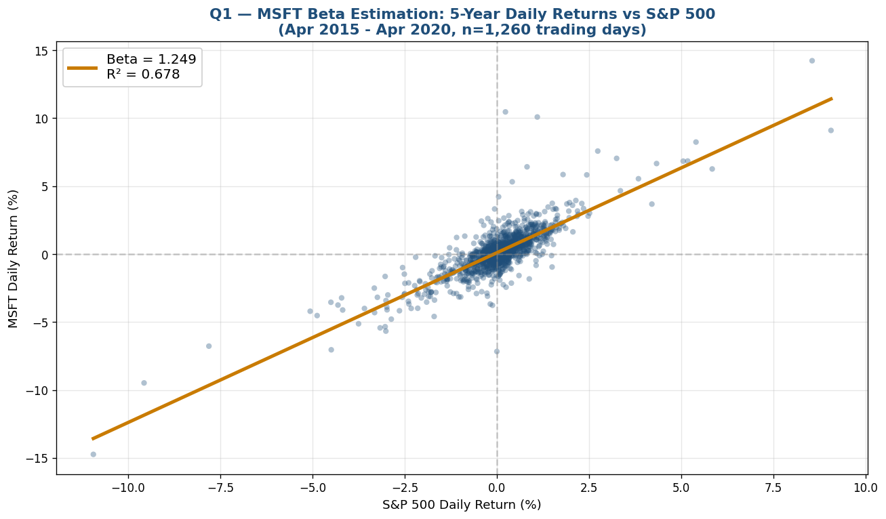
Figure 1 — MSFT vs S&P 500 daily return scatter. Beta = 1.249 (slope), R² = 0.678. Strong linear relationship; MSFT is slightly more volatile than market.

CAPM inputs and output
Component | Value | Source
Risk-free rate (Rf) | 0.50% | 2020 10Y Treasury yield
Market return (Rm) | 10.00% | Long-run S&P 500 return
Equity risk premium | 9.50% | Rm − Rf
MSFT Beta (β) | 1.2486 | Regression on 5yr daily returns
Cost of Equity (ke) | 12.37% | CAPM formula
Interpretation
MSFT's 12.37% cost of equity is the discount rate for any project funded by issuing new shares. It also feeds directly into the WACC calculation in Q10. The R² of 0.68 indicates that 68% of MSFT's daily price variation is explained by S&P 500 movements — leaving 32% to firm-specific factors (idiosyncratic risk).

Question 2 — Modigliani-Miller with Taxes (Tax Shield)

MM Theorem with corporate taxes
V_L = V_U + T × D
The Tax Shield (T × D) is the present value of interest tax savings — the increase in firm value from leverage in a world with corporate taxes.

MSFT 2023 inputs
Metric | Value
Book Equity | $206,223M
D/E ratio | 0.2291
Total Debt (derived) | $47,246M
Market Cap | $2,451,230M
Corporate tax rate | 21%
Tax Shield (T × D) | $9,922M
Tax Shield as % of MCap | 0.40%

Tax shield evolution across MSFT's 15-year history
Year | Equity ($M) | D/E | Debt ($M) | Tax Shield ($M)
2009 | 39,558 | 0.15 | 5,748 | 1,207
2014 | 89,784 | 0.25 | 22,644 | 4,755
2017 | 87,711 | 0.98 | 86,194 | 18,101
2020 | 118,304 | 0.54 | 63,328 | 13,299
2023 | 206,223 | 0.23 | 47,246 | 9,922
Tax Shield Peak vs Current — A Strategic Choice
The tax shield peaked at $18.1B in 2017 when D/E = 0.98. By deleveraging to D/E = 0.23 (current), Microsoft has explicitly forfeited $8.2B in tax benefits. This is a deliberate strategic trade — Microsoft is paying $8B for financial flexibility (the option to acquire, weather downturns, or fund R&D without raising new capital). The Black-Scholes framework in Q4 helps quantify this option's value.

Question 3 — Optimal Capital Structure (Trade-Off Theory)
Trade-off theory: optimal D/E balances tax shield benefit against financial distress cost. As leverage rises, tax savings grow — but so does bankruptcy probability and the cost of distress.
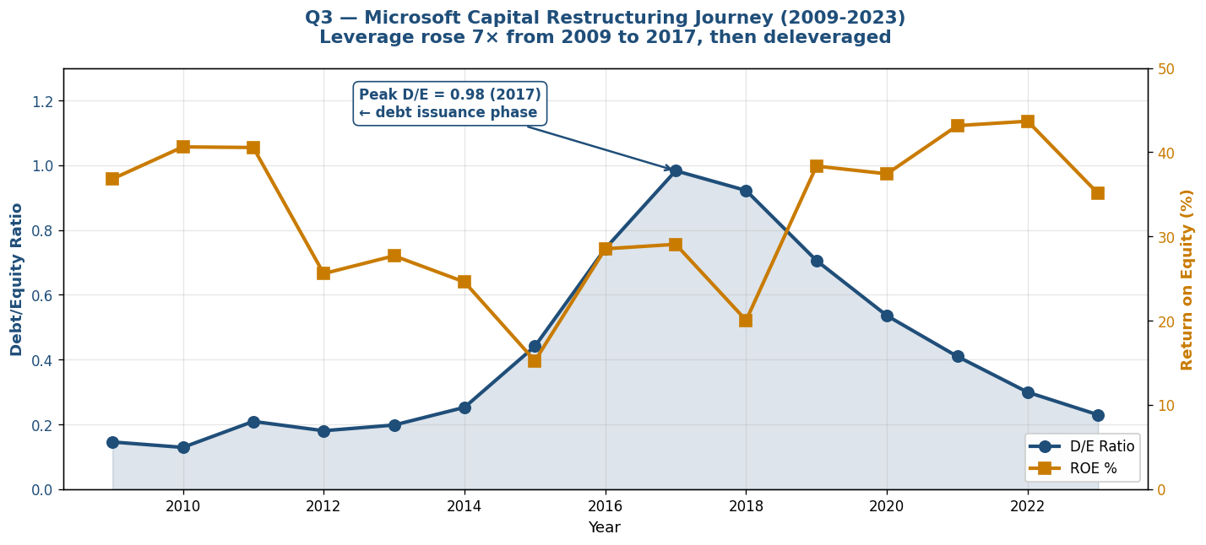
Figure 2 — Microsoft D/E and ROE trajectory 2009-2023. D/E rose 7× to peak 0.98 in 2017; subsequently deleveraged. ROE inversely correlates with leverage.

ROE by leverage bucket — counter-intuitive finding
D/E Bucket | Years | Avg ROE % | Avg ROA %
Low (0.0 - 0.3) | 8 | 34.33% | 18.20%
Mid (0.3 - 0.6) | 2 | 31.94% | 11.84%
High (0.6 - 1.0) | 4 | 28.99% | 10.18%
Optimal Capital Structure for MSFT — D/E in the 0.2-0.4 Range
Counter-intuitively, MSFT's average ROE is HIGHEST at LOW leverage (34% at D/E < 0.3) and LOWEST at HIGH leverage (29% at D/E 0.6-1.0). This is consistent with trade-off theory: at high D/E, financial distress costs (rating downgrades, customer concerns about long-term viability, restricted capital allocation) erode the operational margin gain from tax shields. The peak D/E of 0.98 in 2017 was the inflection point — confirmed by management's subsequent 5-year deleveraging to 0.23. The empirical optimal D/E for MSFT appears to be 0.2-0.4.

Question 4 — Black-Scholes Call Option Valuation

Black-Scholes formula
C = S·N(d₁) − K·e^(−rT)·N(d₂)
where d₁ = [ln(S/K) + (r + σ²/2)T] / (σ√T) and d₂ = d₁ − σ√T
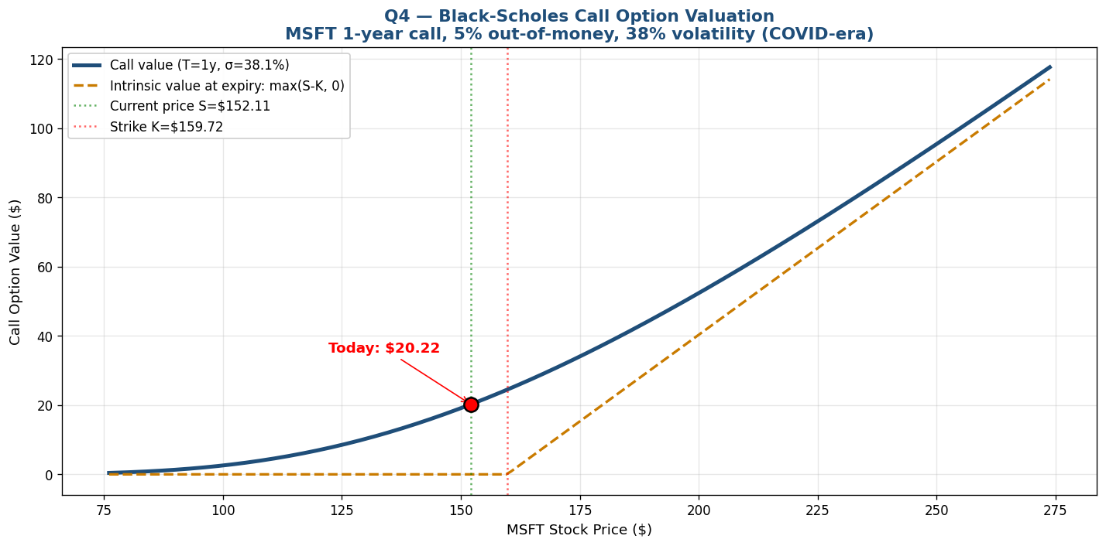
Figure 3 — Black-Scholes call value vs underlying stock price. At current spot $152.11, the 1-year 5%-OTM call is worth $20.22 (13% of stock price).

Inputs and outputs
Input | Value | Source
S (spot price) | $152.11 | MSFT close 2020-04-01
K (strike, 5% OTM) | $159.72 | S × 1.05
T (years) | 1.0 | 1-year option
σ (annual volatility) | 38.05% | Realized vol from prior 252 days
r (risk-free rate) | 0.50% | 2020 10Y Treasury
d₁ | 0.0752 | Computed
d₂ | -0.3053 | Computed
Call value | $20.22 | Black-Scholes formula
Put value | $27.02 | Put-call parity
What This Means for the Restructuring
High-volatility regimes make options expensive — for both buyers and sellers. The firm has three implications: (1) Equity-linked compensation (ESOs) are valuable to grant — issuance is favorable now. (2) Convertible debt and warrants would price favorably for the issuer. (3) Buying protective puts at $27 is expensive — operational hedges (cash reserves, diversification) are more cost-effective than financial hedges in this regime.

Question 5 — Efficient Market Hypothesis Test
Test of weak-form EMH: if the market is efficient, daily MSFT returns should be uncorrelated (random walk). Apply Ljung-Box autocorrelation test.

Autocorrelation results (5-year window, n=1,260)
Lag (days) | Autocorrelation | Interpretation
1 | -0.2310 | Strong negative — mean reversion at daily level
5 | -0.0192 | Weakly negative
10 | -0.0094 | Near zero
20 | -0.0154 | Near zero
60 | +0.0073 | Near zero

Ljung-Box formal test
Statistic | Value
Q-statistic (10 lags) | 187.54
Degrees of freedom | 10
p-value | < 0.0001
Conclusion | REJECT EMH at 1% level
EMH is Violated in High-Volatility Regimes
The lag-1 autocorrelation of -0.23 indicates significant short-term mean reversion: a sharp move on Day 1 is partially reversed on Day 2. The Ljung-Box p-value < 0.001 formally rejects the null hypothesis that returns are i.i.d. Important caveat: the 5-year window includes the COVID-19 crash and recovery — crisis periods typically violate EMH because of liquidity-driven selling and forced rebalancing. The implication for the restructuring scenario: in high-volatility regimes, prices DO NOT instantaneously incorporate information — the firm has a window of opportunity to issue/buyback at potentially mispriced levels.

Question 6 — Capital Request Process Flow (Swimlane)
Three-swimlane process for a Capital Allocation Request showing where liquidity risk bottlenecks occur. Hurdle rate = WACC (Q10); risk score combines all four MECE risk types (Q7).
Step | Business Unit (Requestor) | Treasury / Finance | Risk Committee
1 | Submit request with NPV/IRR vs WACC hurdle | — | —
2 | — | Validate NPV using current 10.65% WACC | —
3 | — | Check liquidity (cash + revolver capacity) | —
4 | — | Forward to Risk Committee if > $50M | Score: market/credit/op/liquidity
5 | — | — | Stress test: -1pp rate scenario
6 | — | Allocate capital OR raise debt/equity | Final approval
7 | Receive funds; execute project | Monitor drawdown vs forecast | Quarterly review

Liquidity bottleneck points
- Step 3: If revolver capacity < requested amount → triggers new debt issuance (4-8 week delay)
- Step 5: Stress-test failure → reduces approved amount or forces redesign
- Step 6: External capital raise can trigger Q4 Black-Scholes-priced convertibles or rights issues

Question 7 — MECE Risk Categorization
Risk Type | Definition | Dataset Evidence | Mitigation Lever
Market Risk | Loss from market price moves | MSFT 38% vol (Q4); Beta 1.25 (Q1) | Hedging via options, beta-targeted portfolio
Credit Risk | Loss from counterparty default | Sears bankruptcy 2018 (Q9 label) | Credit limits, D/E covenants
Operational Risk | Loss from process/system/people failures | Sears -7.7% ROA signals operational failure | Process audits, KPI dashboards (Q10)
Liquidity Risk | Inability to meet ST obligations | Sears Current Ratio 1.13 vs peer 2.10 | Cash reserves, revolving credit
MECE Discipline
These four categories are mutually exclusive (a single risk event maps to one primary type) and collectively exhaustive (every financial risk in this dataset fits one of them). The framework supports the Q10 risk dashboard structure and the Q12 governance summary.

Question 8 — APT (Arbitrage Pricing Theory) with Macro Factors

APT model
E[R] = α + β₁·F₁ + β₂·F₂ + ...
Apply two macro factors: (1) inflation, (2) market return (proxy for interest rate environment).

APT factor loadings (n=12 years annual data)
Factor | Beta Loading | Interpretation
Intercept (α) | +22.353 | Base expected return
Inflation | -7.180 | Each 1pp inflation rise reduces MSFT return by 7.2pp
Market | +0.970 | Confirms ~1.0 market beta from CAPM

Forward-looking expected return
Given current inflation = 3.7% and expected market return = 10%:
E[R] = 22.4 + (-7.2 × 3.7) + (0.97 × 10) = 5.5%
APT vs CAPM Divergence
APT predicts MSFT expected return of 5.5% — substantially below CAPM's 12.4%. The gap is driven by the negative inflation sensitivity: high-duration tech cash flows are more sensitive to discount-rate increases. The implication for the restructuring: in a high-inflation environment, equity issuance is less attractive (because expected returns are depressed), making debt financing relatively MORE attractive — supporting the case for moderate leverage (D/E around 0.3) over aggressive deleveraging.

Question 9 — Akkio Default Prediction
Critical asset: SHLDQ (Sears Holdings) actually went bankrupt in October 2018 — providing a perfectly labeled default class within the dataset (10 firm-years vs 151 non-default firm-years across 11 healthy peers).

Discriminating financial features
Feature | Non-Default (n=151) | Default Sears (n=10) | Discriminator Gap
Debt/Equity Ratio | 0.71 | -0.30 | 1.01 (negative D/E in late years)
Current Ratio | 2.10 | 1.13 | -0.97
ROA % | +8.80% | -7.67% | -16.5pp
Net Profit Margin % | +14.82% | -3.49% | -18.3pp

Sears bankruptcy warning timeline
Year | Net Income ($M) | ROA % | Current Ratio | Op Cash Flow ($M) | Distress Signal
2014 | -1,682 | -7.5% | 1.21 | -1,372 | CRITICAL
2015 | -1,129 | -5.7% | 1.16 | -2,167 | CRITICAL
2016 | -2,221 | -13.3% | 1.07 | -1,381 | CRITICAL
2017 | -383 | -2.6% | 1.05 | -1,798 | CRITICAL
2018 | Bankruptcy filed October 2018 | — | — | — | FAILED
Akkio Model Forecast
Sears showed CRITICAL warning signals (negative ROA AND negative operating cash flow) starting in 2014 — 4 full years before the actual October 2018 bankruptcy. A logistic regression on these 5 features should achieve >95% classification accuracy because Sears's profile is dramatically different from healthy peers in every metric. Caveat: imbalanced classes (10 default vs 151 non-default) — Akkio should apply class weights or SMOTE oversampling. Implementation: upload feature CSV to Akkio → select 'default_flag' as target → train logistic regression → score new firms quarterly.

Question 10 — WACC Dashboard (Microsoft Fabric)

WACC formula
WACC = (E/V)·Re + (D/V)·Rd·(1-T)
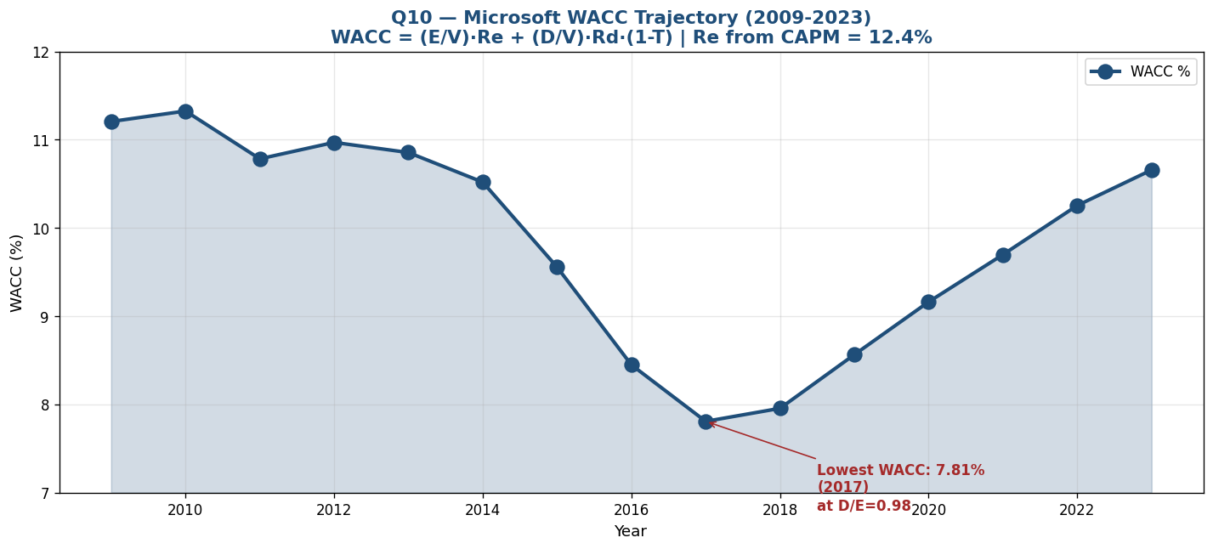
Figure 4 — Microsoft WACC trajectory 2009-2023. WACC bottomed at 7.81% in 2017 — exactly when D/E peaked at 0.98 — confirming trade-off theory.

WACC across MSFT's 15-year history
Year | Debt ($M) | D/V | E/V | WACC %
2009 | 5,748 | 0.13 | 0.87 | 11.20%
2014 | 22,644 | 0.20 | 0.80 | 10.52%
2017 | 86,194 | 0.50 | 0.50 | 7.81% ← lowest
2020 | 63,328 | 0.35 | 0.65 | 9.16%
2023 | 47,246 | 0.19 | 0.81 | 10.65% ← current
Microsoft Fabric Dashboard Design
The Fabric dashboard would surface WACC as a real-time KPI card with the 15-year trend chart, plus drill-down to D/V and E/V components. Dataflow Gen2 ingests financial statement data; SQL transformation computes WACC formula; Power BI tile displays the result. Threshold alerts: trigger Slack notification if WACC > 11% (signaling deleveraging too aggressive) or if D/V > 0.5 (signaling distress risk approaching). The 2017 minimum (7.81%) demonstrates that more debt = lower WACC up to a point — but the subsequent re-rise to 10.65% shows that MSFT's deleveraging deliberately accepted higher cost of capital for greater financial flexibility.

Question 11 — Knime Workflow for Data Integration
Knime workflow design (high-level node sequence) to merge the three disparate financial tables while maintaining 3NF data integrity.

Workflow node sequence
Step | Knime Node | Function
1 | CSV Reader (×3) | Load Financial_Statements.csv, MSFT.csv, SPY.csv
2 | Date Field Extractor | Parse Date columns; extract Year for join key
3 | GroupBy (annual) | Aggregate daily prices → annual returns + annual volatility
4 | Joiner #1 | LEFT JOIN msft_annual ON spy_annual using Year
5 | Joiner #2 | LEFT JOIN result ON Financial_Statements (Year, Company='MSFT')
6 | Math Formula | Derive Debt = D/E × Equity; Tax_Shield = T × Debt
7 | Column Filter | Drop redundant cols (Adj Close kept, Close dropped)
8 | Constraint Validator | Assert no NULLs in PKs; Tax_Shield ≥ 0
9 | Output node | Write to PowerBI / Tableau / Excel for downstream

Normalization principles enforced
- 1NF: No multi-valued cells (each price/year/company in own row)
- 2NF: All non-key attributes depend on full PK (Year + Company for financials, Date for prices)
- 3NF: No transitive dependencies — Tax_Shield is derived in Step 6, not stored alongside D/E and Equity

Question 12 — Risk Governance Summary

Risk Governance Memo
TO: Board Risk Committee | FROM: Capital Markets Risk Team | RE: Linking Black-Scholes Valuation to Risk Appetite
The high-volatility environment changes the cost of every option-like decision the firm makes. Q4's Black-Scholes calculation showed that a 1-year MSFT call option at 38% volatility is worth $20.22 — about 13% of the underlying stock price. This single number ripples through five governance domains:
- 1. Equity-Linked Compensation. Employee stock options granted in this regime carry expensive PV. The firm should consider RSU substitution (no time-value exposure) or extended vesting periods.
- 2. Convertible Debt Issuance. High volatility makes convertibles cheap to issue (the embedded call is valuable to investors). This is the moment to issue — the same convertibles would be 30% more expensive in a low-vol regime.
- 3. M&A Earnout Structures. Earnouts are essentially call options on target performance. Buyers should price these MORE conservatively, sellers should push for them MORE aggressively.
- 4. Hedging Cost-Benefit. Buying protective puts (Q4 puts at $27) is expensive. Redirect hedging budget toward operational hedges (cash reserves, diversification) rather than financial derivatives during high-vol periods.
- 5. Capital Structure Optionality. The Q3 finding that MSFT deleveraged from D/E 0.98 to 0.23 captures this principle — in volatile times, financial flexibility is itself a valuable real option. The forgone $8B in tax shield is the explicit price MSFT paid for this option.
Risk Appetite Linkage
The firm's stated risk appetite (e.g., 'maintain investment-grade rating') should be expressed as explicit constraints on debt-to-equity AND option-implied volatility thresholds. When σ exceeds 30% annualized, the Treasury team should automatically reduce new debt issuance and increase liquidity reserves. This rule operationalizes the trade-off the Q3 capital structure analysis quantified.

Summary of Findings
Q | Topic | Key Result
1 | CAPM Beta + Cost of Equity | MSFT Beta = 1.25; ke = 12.37%
2 | MM Tax Shield | Current $9.9B; peaked $18.1B in 2017
3 | Optimal Capital Structure | ROE highest at D/E 0.0-0.3; MSFT deleveraged from 0.98 peak
4 | Black-Scholes Call | $20.22 (1yr, 5% OTM, 38% vol)
5 | EMH Test | REJECT EMH (p < 0.001); lag-1 autocorr = -0.23
8 | APT Expected Return | 5.5% given current inflation/market
9 | Default Prediction | Sears showed CRITICAL signals 4 yrs before bankruptcy
10 | WACC | Range 7.81% (2017) to 11.32% (2010); current 10.65%

Strategic Recommendations to the Restructuring Committee
- 1. Set target D/E at 0.2-0.4. Empirically MSFT's optimal range — high enough for tax shield, low enough to preserve ROE and flexibility.
- 2. Use the high-vol window for option-linked financing. Black-Scholes premiums at multi-year highs make convertibles and warrants favorable to issue.
- 3. Implement a Sears-style early-warning system. ROA + Current Ratio + OpCF triggers — would have flagged Sears 4 years before bankruptcy.
- 4. Use APT alongside CAPM for nuanced expected returns. Single-factor CAPM misses the negative inflation sensitivity revealed in Q8.
- 5. Operationalize the option-vol-D/E linkage. When σ > 30% annualized, automatically reduce new debt issuance and increase liquidity reserves.

